Unveiling the Link Between Technological Disclosure and Efficiency: An Analytical Study of India’s Manufacturing Sector Using NLP Techniques

Submitted by-
Chitranjan Kumar

Contents
EXECUTIVE SUMMARY 5
CHAPTER 1: INTRODUCTION 6
1.1 Background and Context 6
1.2 Research Objectives 7
1.3 Scope and Limitations 7
1.4 Structure of the Report 8
CHAPTER 2: LITERATURE REVIEW 9
2.1 Corporate Disclosure Theory 9
2.2 Textual Analysis of Corporate Communications 10
2.3 Technology Adoption in Indian Manufacturing 11
2.4 NLP Approaches to Corporate Communication Analysis 12
2.5 Theoretical Framework 12
CHAPTER 3: RESEARCH METHODOLOGY 14
3.1 Research Design 14
3.2 Sample Selection 14
3.3 Data Collection 16
3.4 Technology Vocabulary Construction 16
3.5 NLP Analysis Procedure 17
3.6 Analytical Framework 17
CHAPTER 4: ANALYSIS AND RESULTS 18
4.1 Overview of the Dataset 18
4.2 Adani Power Ltd 18
4.2.1 Company Background 18
4.2.2 Year-wise Technology Term Analysis 19
4.2.3 Consolidated Technology Analysis 21
4.3 Asian Paints Ltd 22
4.3.1 Company Background 22
4.3.2 Year-wise Technology Term Analysis 22
4.3.3 Consolidated Technology Analysis 24
4.4 Britannia Industries Ltd 24
4.4.1 Company Background 24
4.4.2 Year-wise Technology Term Analysis 25
4.4.3 Consolidated Technology Analysis 26
4.5 Dabur India Ltd 27
4.5.1 Company Background 27
4.5.2 Year-wise Technology Term Analysis 27
4.5.3 Consolidated Technology Analysis 29
4.6 Hindustan Unilever Ltd 30
4.6.1 Company Background 30
4.6.2 Year-wise Technology Term Analysis 30
4.6.3 Consolidated Technology Analysis 32
4.7 Tata Steel 33
4.7.1 Company Background 33
4.7.2 Year-wise Technology Term Analysis 33
4.7.3 Consolidated Technology Analysis 35
4.8 UltraTech Cement Ltd 36
4.8.1 Company Background 36
4.8.2 Year-wise Technology Term Analysis 36
4.8.3 Consolidated Technology Analysis 38
4.9 Varun Beverages Ltd 39
4.9.1 Company Background 39
4.9.2 Year-wise Technology Term Analysis 39
4.9.3 Consolidated Technology Analysis 41
4.10 United Spirits Ltd 42
4.10.1 Company Background 42
4.10.2 Year-wise Technology Term Analysis 42
4.10.3 Consolidated Technology Analysis 44
4.11 Vedanta Ltd 45
4.11.1 Company Background 45
4.11.2 Year-wise Technology Term Analysis 45
4.11.3 Consolidated Technology Analysis 48
4.12 Cross-Company Comparative Analysis 49
4.12.1 Consolidated Technology Term Rankings 49
4.12.2 Total Technology Disclosure Volume Comparison 51
4.12.3 Category-Level Vocabulary Composition Across Companies 52
4.12.4 Pre-COVID vs Post-COVID Technology Disclosure Comparison 53
4.13 Temporal Trend Analysis: The Evolution of Technology Discourse (2013–2025) 54
4.13.1 Phase 1: Foundational IT (2015–2016) 55
4.13.2 Phase 2: Digital Awareness (2017–2018) 55
4.13.3 Phase 3: Digital Transformation and Analytics (2019–2020) 55
4.13.4 Phase 4: Cybersecurity and Platform Intelligence (2021–2022) 56
4.13.5 Phase 5: AI Dominance (2023–2025) 56
4.14 Sector-Specific Technology Disclosure Patterns 56
4.14.1 Heavy Manufacturing and Infrastructure (Tata Steel, Vedanta, Adani Power) 56
4.14.2 FMCG Consumer Goods (HUL, Dabur, Britannia) 57
4.14.3 Building Materials (UltraTech Cement) 57
4.14.4 Beverages (Varun Beverages, United Spirits) 57
4.14.5 Specialised Manufacturing (Asian Paints) 58
CHAPTER 5: CONCLUSIONS, IMPLICATIONS, AND RECOMMENDATIONS 59
5.1 Summary of Key Findings 59
5.2 Theoretical Implications 60
5.3 Practical Implications 60
5.4 Limitations and Areas for Future Research 61
5.5 Conclusion 62
REFERENCES 64
APPENDIX A: COMPLETE TECHNOLOGY VOCABULARY 65
APPENDIX B: Python Code for NLP-Based Technology Disclosure Analysis 67

EXECUTIVE SUMMARY
This Management Project analyses how technological disclosure has evolved within India’s manufacturing sector and what it reveals about firms’ strategic orientation toward digital transformation and operational efficiency. As Industry 4.0, artificial intelligence, and cybersecurity reshape industrial operations, understanding how companies communicate their technology initiatives provides valuable insight into their transformation journey.
The study examines 103 annual reports spanning financial years 2013–2025 for ten leading Indian manufacturing companies: Adani Power Ltd, Asian Paints Ltd, Britannia Industries Ltd, Dabur India Ltd, Hindustan Unilever Ltd, Tata Steel, UltraTech Cement Ltd, Varun Beverages Ltd, United Spirits Ltd, and Vedanta Ltd. These firms represent diverse sub-sectors including energy, metals, cement, FMCG, and beverages, enabling both cross-industry and longitudinal analysis.
A dictionary-based Natural Language Processing (NLP) approach was used to analyse technology-related vocabulary within the annual reports. A structured dictionary of over eighty technology terms, grouped into ten categories-including AI and Machine Learning, Data Analytics, Automation, Cloud and IT Infrastructure, ERP systems, IoT, Industry 4.0, Cybersecurity, Digital Transformation, and Sustainability Technologies-was applied consistently across all documents to measure disclosure intensity and trends.
The findings show a clear and sustained rise in technology-related disclosure across the study period. Early years were dominated by foundational IT terms such as ERP and SAP. Over time, the narrative expanded to include automation, digital transformation, and analytics.
Vedanta Ltd records the highest cybersecurity disclosure (110 cumulative mentions), while Tata Steel leads in AI frequency (109 cumulative mentions). Heavy manufacturing firms demonstrate greater intensity in Industry 4.0 and automation discourse, whereas FMCG companies show stronger emphasis on digital transformation and analytics. Beverage companies display comparatively restrained disclosure patterns.
Overall, the study demonstrates that technology disclosure in Indian manufacturing has shifted from operational reporting to strategic positioning. By applying NLP to corporate communications, the research provides a structured and scalable framework for understanding digital maturity trends within India’s industrial landscape.

CHAPTER 1: INTRODUCTION

1.1 Background and Context
The contemporary business environment is defined by rapid and continuous technological change. Digital transformation, artificial intelligence (AI), machine learning, the Internet of Things (IoT), cloud computing, and advanced analytics are no longer confined to technology firms, they have become central to strategy across industries. Manufacturing, traditionally viewed as capital-intensive and process-driven, is now undergoing structural transformation driven by digital integration and intelligent automation.
In India, the manufacturing sector contributes roughly 17 percent of national GDP and provides employment to millions. As the country seeks to strengthen its global competitiveness, manufacturing firms face a dual imperative: improving operational efficiency while simultaneously adapting to emerging digital technologies. The challenge is not merely technological adoption, but strategic alignment-integrating digital capabilities into core production, supply chain, and governance processes.
Corporate annual reports play a critical role in communicating this transformation. Beyond financial performance, annual reports include management discussions, chairman’s statements, operational reviews, and risk disclosures that reflect strategic priorities. The way firms discuss technology in these documents-through the frequency, emphasis, and type of technology-related terminology used-provides meaningful signals about their digital orientation, investment focus, and long-term positioning.
The Indian manufacturing landscape is further shaped by significant policy initiatives such as the Make in India programme (launched in 2014), the Digital India Mission, Production-Linked Incentive (PLI) schemes across multiple sectors, and national efforts to promote Industry 4.0 adoption. These domestic initiatives coincide with global developments, including the digital acceleration triggered by the COVID-19 pandemic (2020–2021) and the rapid rise of AI-driven technologies following the emergence of large language models from 2023 onwards. Together, these forces create a dynamic environment in which technology communication has become both strategically important and institutionally expected.
Understanding how Indian manufacturing firms communicate their technological orientation within this evolving context is therefore both timely and relevant.

1.2 Research Objectives
This study pursues six primary research objectives. First, to measure the frequency and distribution of technology-related vocabulary in the annual reports of ten Indian manufacturing companies over the study period. Second, to identify year-wise trends in technology disclosure for each company, detecting inflection points and phase transitions. Third, to analyse the composition of technology vocabulary, the categories of technology being communicated, and how this composition has evolved over time. Fourth, to conduct cross-company comparative analysis to identify similarities and differences in technology disclosure patterns across sub-sectors. Fifth, to contextualise the technology disclosure trends within the broader macro-environment of policy initiatives, global technology developments, and pandemic-related disruptions. Sixth, to draw insights about the relationship between technology disclosure intensity and the likely technology adoption maturity of the companies studied.

1.3 Scope and Limitations
This study is based on publicly available annual reports of the ten companies, as filed with the Bombay Stock Exchange (BSE) and National Stock Exchange (NSE) or published on company websites. The analysis covers different time spans for different companies depending on data availability, ranging from 2013 to 2025. It is important to note that this study measures technology disclosure-the language about technology in corporate communications-rather than actual technology investment or adoption. A company may invest significantly in technology while communicating about it conservatively, and vice versa. This caveat is critical to interpreting the findings appropriately. Additionally, the dictionary-based NLP approach may capture acronym ambiguity and does not account for the contextual meaning or sentiment of technology mentions.

1.4 Structure of the Report
The remainder of this report is structured as follows.
Chapter 2 provides a comprehensive review of the relevant literature spanning corporate disclosure theory, textual analysis of annual reports, technology adoption in Indian manufacturing, and NLP methodologies applied to corporate communications.
Chapter 3 describes the research methodology in detail, including the company selection criteria, data collection approach, vocabulary construction, and analytical framework.
Chapter 4 presents the detailed analysis and results, covering individual company profiles, year-wise and consolidated technology term analysis, cross-company comparative analysis, temporal trend analysis, and sector-specific observations.
Chapter 5 concludes with findings, theoretical and practical implications, limitations, and recommendations for future research.

CHAPTER 2: LITERATURE REVIEW

2.1 Corporate Disclosure Theory
The theoretical foundation of this study is grounded in information economics and corporate disclosure theory. Voluntary disclosure theory, developed by Verrecchia (1983) and Dye (1985), suggests that firms choose to disclose information when the expected benefits outweigh the associated costs. These benefits include reduced information asymmetry, lower cost of capital, and improved investor confidence. The costs may involve revealing strategic or proprietary information that could weaken competitive advantage. In the context of technology disclosure, companies that are actively investing in digital transformation may have stronger incentives to communicate these initiatives. Doing so can attract investors who value innovation and signal that the firm is strategically aligned with modern technological trends.
Signalling theory, originally proposed by Spence (1973), offers an additional perspective. In corporate communication, language itself can function as a signal. The use of technology-related vocabulary in annual reports can indicate a firm’s technological capability and strategic direction. Detailed and technically precise discussion of digital initiatives may suggest genuine investment and structured implementation. In contrast, broad or generic references to innovation may reflect aspirational positioning rather than substantive technological integration. From this viewpoint, technology disclosure becomes a mechanism through which firms differentiate themselves and communicate competitive strength.
Legitimacy theory, as discussed by Patten (1992), introduces a third dimension. According to this perspective, firms disclose information not only to signal strength or reduce information asymmetry, but also to align with societal and institutional expectations. As digital transformation has become widely recognised as essential for modern manufacturing, companies face increasing pressure to demonstrate technological progress. Particularly in the post COVID environment, where digital resilience and cybersecurity preparedness are seen as critical, technology disclosure can serve as a means of maintaining organisational legitimacy. Even firms with limited technological depth may increase disclosure to meet stakeholder expectations and avoid being perceived as outdated.
Together, these three theoretical perspectives provide a comprehensive framework for understanding why firms communicate technology-related information in their annual reports and how such communication can reflect both strategic intent and institutional pressure.

2.2 Textual Analysis of Corporate Communications
Textual analysis has become an established method for examining corporate communication, particularly in the context of annual reports and regulatory filings. Early work by Bowman (1984) demonstrated that content analysis of annual reports could reveal strategic insights that extend beyond traditional financial statements. This marked an important shift in recognising narrative disclosures as meaningful sources of information rather than supplementary commentary.
Subsequent research strengthened this approach. Loughran and McDonald (2011) developed a specialised financial dictionary to analyse sentiment in corporate filings, showing that linguistic patterns in 10-K reports contain valuable information about firm performance and risk. Similarly, Li (2010) applied machine learning techniques to identify forward-looking statements in corporate disclosures and found that the tone and specificity of such statements can predict future earnings outcomes. These studies collectively establish that corporate language is not neutral; it carries measurable informational value.
More recent research has expanded textual analysis into areas such as innovation and technology disclosure. Feldman et al. (2010) and Garcia and Norli (2012) demonstrate that changes in managerial tone are economically meaningful and often precede observable performance shifts. Gentzkow, Kelly, and Taddy (2019) further systematise the “text as data” approach, providing a methodological foundation for extracting structured insights from large document collections using reproducible techniques. Their framework supports the use of consistent, rule-based text processing methods, which aligns directly with the dictionary-based NLP approach adopted in this study.
Together, this body of literature validates the use of textual analysis as a credible and rigorous method for studying corporate communication, including technology-related disclosure in annual reports.

2.3 Technology Adoption in Indian Manufacturing
Technology adoption in Indian manufacturing has gained increasing momentum over the past decade. As global industries transition toward Industry 4.0 and smart manufacturing models, Indian firms are gradually integrating digital technologies into production, supply chain, and operational systems. However, the pace and depth of adoption vary across sectors depending on capital intensity, scale of operations, and strategic priorities.
Smart manufacturing frameworks typically emphasise the integration of digital systems, automation, data analytics, and intelligent decision-making tools within production environments. In the Indian context, many firms began their digital journey with foundational enterprise systems such as ERP and SAP, which helped standardise processes and improve operational visibility. Over time, this foundation has enabled gradual expansion into automation, advanced analytics, IoT-enabled monitoring, and AI-driven optimisation.
The evolution of digital adoption in Indian manufacturing has not been uniform. Large, capital-intensive firms have generally progressed faster due to greater investment capacity and stronger infrastructure support. In contrast, smaller or less capital-intensive firms often adopt technology incrementally, focusing first on operational efficiency and cost optimisation before moving toward advanced digital transformation initiatives.
The COVID-19 pandemic acted as a significant catalyst for digital acceleration. Disruptions in supply chains, remote working requirements, and heightened cybersecurity risks pushed firms to strengthen their digital infrastructure and invest in automation and analytics. More recently, the rapid global emergence of artificial intelligence has further intensified attention toward AI integration within manufacturing operations.
Overall, technology adoption in Indian manufacturing reflects a gradual but clear shift from basic enterprise digitisation toward more advanced and integrated digital transformation strategies. This broader industry evolution provides essential context for analysing how companies communicate their technological priorities in annual reports.

2.4 NLP Approaches to Corporate Communication Analysis
Dictionary-based approaches to NLP, as employed in this study, are well-established in the corporate communication literature. The Loughran-McDonald financial sentiment dictionary (2011) represents the gold standard for financial text analysis and has been applied in hundreds of subsequent studies. Krippendorff (2004) provides the methodological foundations for content analysis as a research method, emphasising the importance of clearly defined coding categories and reproducible procedures.
More recent NLP approaches have moved towards machine learning-based methods, including supervised classification, topic modelling, and transformer-based language models. However, dictionary-based approaches remain particularly appropriate for studies like the current one, where the researcher has a priori knowledge of the specific vocabulary of interest (technology terms) and wishes to study their frequency and distribution rather than discovering latent topics. The interpretability and reproducibility of dictionary-based methods are additional advantages in an academic research context.
Aziz and Mukherjee (2022) represent the closest precedent for the current study, analysing digital transformation language in Indian FMCG annual reports using a text mining approach. Their finding that digital transformation vocabulary predicts outperformance in revenue growth provides suggestive evidence for the relevance of technology disclosure as a strategic signal, complementing the current study's descriptive approach.

2.5 Theoretical Framework
Drawing on the above literature, this study adopts a theoretical framework that positions technology vocabulary in annual reports as a multidimensional signal. At one level, it signals genuine technology investment and strategic intent (signalling theory). At another level, it reflects the evolving expectations of the institutional environment (legitimacy theory). At yet another level, it represents a disclosure choice made in response to the perceived informational needs of investors and other stakeholders (voluntary disclosure theory).
This multi-theoretic framework implies that high technology disclosure intensity—observed empirically in companies like Vedanta, Tata Steel, and Adani Power—is most plausibly interpreted as reflecting a combination of genuine technology adoption, strategic investor communication, and institutional legitimacy imperatives. The framework also implies that low disclosure intensity—as observed in Varun Beverages and United Spirits—reflects conservative communication philosophy, sector norms, or a more focused operational narrative rather than necessarily indicating lower technology investment.

CHAPTER 3: RESEARCH METHODOLOGY

3.1 Research Design
This study adopts a longitudinal, descriptive research design combining content analysis and quantitative text mining methodologies. It is longitudinal in that it examines technology disclosure patterns for each company over a multi-year period (2013–2025) depending on data availability. It is comparative in that it examines the same vocabulary across ten companies and multiple time periods, enabling both intra-company trend analysis and inter-company benchmarking.

3.2 Sample Selection
The ten companies included in this study were selected based on five criteria. First, the company must be a publicly listed manufacturing firm in India, with annual reports available as publicly accessible documents. Second, the company must have a continuous annual report series covering at least eight of the years in the study period. Third, the company must represent a distinct sub-sector of Indian manufacturing, ensuring sector diversity in the sample. Fourth, the company must be among the larger firms in its respective sub-sector by revenue, ensuring that the size of text corpus is sufficient for meaningful frequency analysis. Fifth, the digital transformation journey of the company must be of interest to investors and practitioners, ensuring the policy relevance of the findings.

Table 1presents the ten companies selected for this study with their key characteristics
Table 1: Sample Companies — Overview
Company | Primary Sector | Revenue (FY24) | Data Coverage | Reports
Adani Power Ltd | Energy & Utilities | ₹52,790 Cr | 10 (2015–2024) | 10
Asian Paints Ltd | Consumer Goods (Paints) | ₹34,489 Cr | 10 (2015–2024) | 10
Britannia Industries Ltd | FMCG (Food) | ₹16,067 Cr | 10 (2015–2024) | 10
Dabur India Ltd | FMCG / Healthcare | ₹12,546 Cr | 10 (2015–2024) | 10
Hindustan Unilever Ltd | FMCG (Consumer Goods) | ₹60,580 Cr | 10 (2015–2024) | 10
Tata Steel | Metals & Mining (Steel) | ₹2,29,442 Cr | 10 (2015–2024) | 10
UltraTech Cement Ltd | Cement & Building Materials | ₹68,886 Cr | 10 (2015–2024) | 10
Varun Beverages Ltd | Beverages (FMCG) | ₹16,967 Cr | 10 (2015–2024) | 10
United Spirits Ltd | Beverages (Spirits / FMCG) | ₹10,440 Cr | 11 (2013–2023) | 11
Vedanta Ltd | Metals & Mining (Diversified) | ₹1,47,853 Cr | 12 (2015–2025) | 12

3.3 Data Collection
Annual reports for all ten companies were collected from company investor relations websites and from the Bombay Stock Exchange (BSE) and National Stock Exchange (NSE) filing databases. The annual reports are in PDF format and represent the primary source of textual data for this study. For each company, annual reports were collected from the earliest available year (2013 for United Spirits, 2015 for most others) through the most recent available report (2024 or 2025). In total, 103 annual reports were collected, extracted, and processed.
PDF text extraction was performed using two Python libraries: pdfplumber as the primary tool, and PyMuPDF (fitz) as an alternative for reports where pdfplumber encountered memory or encoding limitations. Both libraries extract raw text from PDF pages, which is then processed through the NLP pipeline described below.

3.4 Technology Vocabulary Construction
The technology vocabulary used in this study comprises over 80 terms organised into ten thematic categories. The vocabulary was constructed through three steps. First, an initial list of technology terms was compiled through a review of academic literature on digital transformation, Industry 4.0, and technology management. Second, the list was supplemented through a review of technology glossaries and reports from industry bodies including NASSCOM, McKinsey, and the World Economic Forum. Third, the final vocabulary was validated against a sample of annual report extracts to ensure comprehensive coverage of technology terms actually appearing in the corpus.
The ten thematic categories of the technology vocabulary are: (1) AI and Machine Learning, (2) Data Analytics, (3) Automation, (4) Cloud and IT Infrastructure, (5) ERP and Enterprise Technology, (6) IoT and Smart Systems, (7) Industry 4.0, (8) Cybersecurity, (9) Digital Transformation, and (10) Energy and Sustainability Technologies. The complete vocabulary is presented in Appendix A.

3.5 NLP Analysis Procedure
The NLP analysis was implemented in Python using the following procedure. First, text was extracted from each PDF annual report using pdfplumber or PyMuPDF. Second, the extracted text was converted to lowercase to enable case-insensitive matching. Third, a regular expression pattern was compiled from the technology vocabulary, with word boundary markers to ensure whole-word matching and avoid partial-word false positives. Fourth, the pattern was applied to the extracted text, and all matching technology terms were collected using Python's Counter data structure. Fifth, year-wise frequency DataFrames were generated for each company, and word cloud visualisations were created from the frequency data. Sixth, consolidated frequency analysis was performed by aggregating term frequencies across all years for each company.
The key analytical outputs for each company are: (a) year-wise frequency table showing the top technology terms and their frequencies for each annual report, (b) consolidated frequency table showing total term occurrences across the entire study period, and (c) word cloud visualisations providing intuitive representations of technology emphasis at both annual and consolidated levels.

3.6 Analytical Framework
The analysis is structured across four levels. The first level is the individual company analysis, examining year-wise trends, identifying inflection points, characterising the technology vocabulary composition, and noting distinctive aspects of each company's disclosure pattern. The second level is the cross-company comparative analysis, directly comparing consolidated technology term frequencies and volumes across all ten companies to identify sector-specific patterns and outliers. The third level is the temporal trend analysis, identifying multi-year patterns across all companies and characterising the evolution of technology discourse into discrete phases. The fourth level is the sector-specific analysis, grouping companies by sub-sector to draw insights about how industry context shapes technology disclosure patterns.

CHAPTER 4: ANALYSIS AND RESULTS

4.1 Overview of the Dataset
This chapter presents the detailed analysis and results of the NLP-based technology disclosure study across ten Indian manufacturing companies. The dataset comprises 103 annual reports spanning financial years 2013–2025, representing approximately 1,500+ pages of corporate text per company across the study period. The analysis is organised as follows: Sections 4.2 through 4.11 present the individual company-level analyses. Section 4.12 presents the cross-company comparative analysis. Section 4.13 presents the temporal trend analysis across the full study period. Section 4.14 examines sector-specific technology disclosure patterns.
In aggregate, the ten-company corpus yields over 3,000 individual technology term occurrences across 103 annual reports, providing a rich empirical basis for the analysis that follows. The distribution of technology terms across companies is highly skewed, with Vedanta Ltd (614 occurrences), Tata Steel (470 occurrences), and Asian Paints Ltd (637 occurrences) accounting for a disproportionate share of the total vocabulary, while Varun Beverages Ltd (96 occurrences) and United Spirits Ltd (75 occurrences) contribute more modestly.

4.2 Adani Power Ltd

4.2.1 Company Background
Adani Power Ltd is one of India's largest private thermal power producers, with an installed capacity exceeding 15,250 MW across multiple plants. As a subsidiary of the Adani Group, the company operates critical national infrastructure. Adani Power's technology priorities are shaped by the imperative to monitor and optimise energy flows, ensure grid reliability, meet growing demands of ESG compliance, and manage cybersecurity risks inherent in connected infrastructure.
The company is categorised within the Energy & Utilities sector, with revenue of approximately ₹52,790 Cr. Data for this study covers 10 (2015–2024).

4.2.2 Year-wise Technology Term Analysis
Table 2 presents the year-wise technology disclosure analysis for Adani Power Ltd.
Table 2: Year-wise Technology Term Frequency - Adani Power Ltd
Year | Top Technology Term | Frequency | Other Notable Terms
2015 | EMS (Energy Mgmt System) | 4 | RPA (2), SAP (1)
2016 | EMS | 4 | RPA (2), SAP (1)
2017 | EMS | 4 | RPA (2), ML (1)
2018 | SAP | 4 | EMS (4), Control Systems (3)
2019 | Energy Management System | 6 | EMS (5), AI (3)
2020 | Energy Management System | 6 | EMS (5), AI (4)
2021 | DCS | 6 | AI (4), Data Security (4)
2022 | AI | 12 | EMS (8), Automation (8), DCS (8), Data Analytics (8)
2023 | Cybersecurity | 32 | AI (31), ML (18)
2024 | Cybersecurity | 30 | AI (27), Information Security (14)

Adani Power exhibits a dramatically bifurcated trajectory: foundational energy management vocabulary dominated 2015–2021, followed by an explosive surge in cybersecurity and AI terms from 2022 onwards. The co-occurrence of these themes reflects the unique challenge of critical infrastructure operators-harnessing AI for operational efficiency while defending against the rising tide of cyber threats to power utilities.

The year-wise data reveals four distinct phases in this company's technology disclosure trajectory:
- 2015-2016: EMS/SAP dominated; low overall volume
- 2017-2019: Continued operational focus; early AI mentions
- 2020-2021: Transition period; DCS and security terms emerge
- 2022-2024: Dramatic surge in AI and Cybersecurity; digital transformation narrative
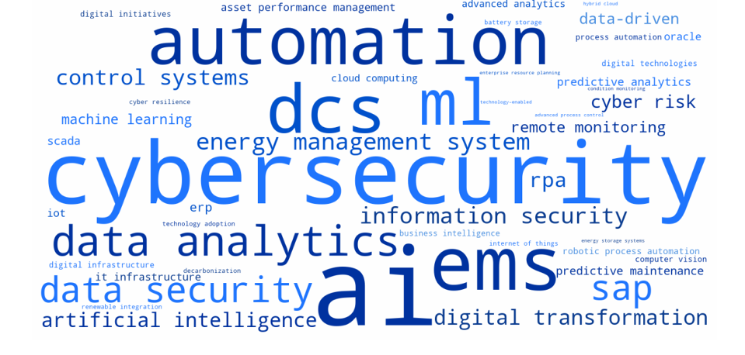
[Figure 1: Word Cloud - Adani Power Ltd (Consolidated All Years)]

4.2.3 Consolidated Technology Analysis
The consolidated technology term frequency for Adani Power Ltd across all study years is as follows: AI (81), Cybersecurity (63), EMS (46), Automation (37), DCS (37), ML (33), Data Analytics (32), Data Security (29), SAP (28), Energy Management System (27).
The total technology term count for Adani Power Ltd across all study years is approximately 413 occurrences, positioning this company as a high-intensity technology discloser relative to the study cohort.
Table 3: Top 5 Consolidated Technology Terms -Adani Power Ltd
Rank | Technology Term | Consolidated Frequency | Category
1 | AI | 81 | AI & Machine Learning
2 | Cybersecurity | 63 | Cybersecurity
3 | EMS | 46 | Energy/Sustainability
4 | Automation | 37 | Automation
5 | DCS | 37 | Energy/Sustainability

4.3 Asian Paints Ltd

4.3.1 Company Background
Asian Paints Ltd is India's largest paint company and one of the top paint companies in Asia, operating in over 15 countries. The company manufactures decorative paints, industrial coatings, and waterproofing solutions. Asian Paints is known for its early adoption of enterprise technology and has historically been a leader in deploying SAP among Indian consumer goods companies. Complex supply chain and distribution management requirements drive its technology adoption.
The company is categorised within the Consumer Goods (Paints) sector, with revenue of approximately ₹34,489 Cr. Data for this study covers 10 (2015–2024).

4.3.2 Year-wise Technology Term Analysis
Table 4 presents the year-wise technology disclosure analysis for Asian Paints Ltd.
Table 4: Year-wise Technology Term Frequency - Asian Paints Ltd
Year | Top Technology Term | Frequency | Other Notable Terms
2015 | RPA | 54 | ERP (6), Control Systems (3)
2016 | RPA | 58 | ERP (4), Control Systems (3), Automation (3)
2017 | Automation | 10 | Control Systems (3), Information Security (2)
2018 | RPA | 26 | SAP (17), ERP (9)
2019 | RPA | 31 | SAP (8), ERP (8)
2020 | RPA | 29 | Automation (11), AI (7)
2021 | RPA | 23 | Automation (8), Data Analytics (7)
2022 | RPA | 22 | Automation (14), Control Systems (8)
2023 | RPA | 29 | Automation (8), Control Systems (7)
2024 | RPA | 29 | Automation (13), Information Security (10)

Asian Paints presents the most distinctive pattern in this study, with RPA dominating across virtually the entire decade (303 cumulative occurrences). This extraordinary frequency reflects both genuine Robotic Process Automation deployment across paint manufacturing and distribution operations, and the possibility of acronym overlap. Beyond RPA, sophisticated enterprise systems vocabulary (SAP, ERP) and growing AI/Information Security discourse from 2020 onwards reveal a company advancing its digital maturity.
The year-wise data reveals four distinct phases in this company's technology disclosure trajectory:
- 2015-2016: RPA extraordinarily dominant; ERP/Control Systems secondary
- 2017-2019: RPA continues; SAP investment prominent
- 2020-2021: Automation and AI begin to emerge alongside RPA
- 2022-2024: Information Security joins top terms; digital sophistication deepening
[Figure 2: Word Cloud — Asian Paints Ltd (Consolidated All Years) ]
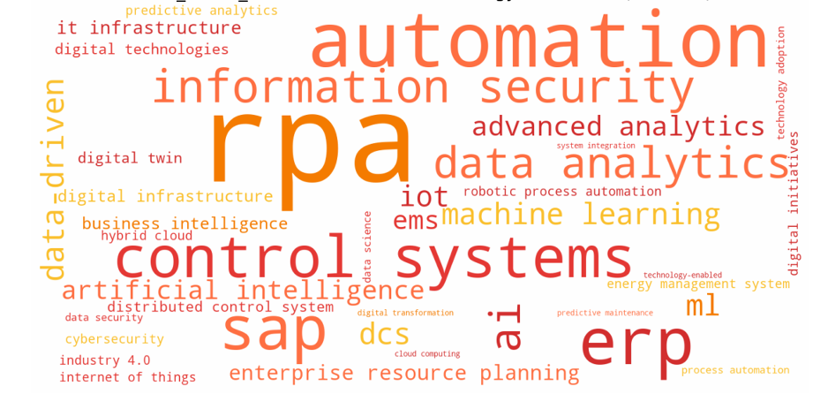

4.3.3 Consolidated Technology Analysis
The consolidated technology term frequency for Asian Paints Ltd across all study years is as follows: RPA (303), Automation (75), ERP (52), SAP (46), Control Systems (41), Information Security (34), Data Analytics (31), AI (30), Data-Driven (13), Machine Learning (12).
The total technology term count for Asian Paints Ltd across all study years is approximately 637 occurrences, positioning this company as a high-intensity technology discloser relative to the study cohort.

Table 5: Top 5 Consolidated Technology Terms -Asian Paints Ltd
Rank | Technology Term | Consolidated Frequency | Category
1 | RPA | 303 | Automation
2 | Automation | 75 | Automation
3 | ERP | 52 | ERP & Enterprise
4 | SAP | 46 | ERP & Enterprise
5 | Control Systems | 41 | Industry 4.0

4.4 Britannia Industries Ltd

4.4.1 Company Background
Britannia Industries Ltd is one of India's largest food companies, known primarily for biscuits, bread, cakes, and dairy products. With over 100 years of history, Britannia operates manufacturing facilities across India and internationally. As a high-volume FMCG food manufacturer, its technology priorities centre on production efficiency, quality control, supply chain management, and food safety compliance. Britannia's conservative technology disclosure profile is consistent with its mature, stable business model.
The company is categorised within the FMCG (Food) sector, with revenue of approximately ₹16,067 Cr. Data for this study covers 10 (2015–2024).

4.4.2 Year-wise Technology Term Analysis
Table 6 presents the year-wise technology disclosure analysis for Britannia Industries Ltd.
Table 6: Year-wise Technology Term Frequency - Britannia Industries Ltd
Year | Top Technology Term | Frequency | Other Notable Terms
2015 | Control Systems | 3 | SAP (2), Automation (2), ERP (1)
2016 | Control Systems | 3 | Automation (2), Process Automation (1), SAP (1)
2017 | Control Systems | 3 | Automation (2), SAP (1)
2018 | IT Infrastructure | 3 | Control Systems (3), AI (2), Automation (2), SCADA (1)
2019 | Control Systems | 3 | Automation (1), SAP (1)
2020 | Control Systems | 3 | AI (2), RPA (2), ERP (1), Data Security (1)
2021 | Control Systems | 3 | RPA (2), Automation (1), ERP (1), SAP (1)
2022 | Multiple (tied) | 2 | Data Security, AI, Automation, Control Systems, RPA—all 2
2023 | AI | 4 | Digital Transformation (3), Automation (3), SAP (3)
2024 | AI | 21 | Automation (5), Digital Transformation (4), Control Systems (3)

Britannia exhibits the most restrained technology disclosure profile in this study—characterised by consistently low term frequencies across most of the decade and a sudden dramatic spike in AI mentions in 2024 (21 mentions vs. 2–4 in prior years). This pattern reflects a communication philosophy shift in 2024, as AI discourse became an investor expectation. The sparse early vocabulary (Control Systems dominating at just 3 occurrences per year) suggests Britannia's technology investments were not prominently communicated in annual reports until recently.
The year-wise data reveals four distinct phases in this company's technology disclosure trajectory:
- 2022: Lowest year overall; all terms tied at 2
- 2023: Modest uptick; AI and Digital Transformation emerge
- 2024: Dramatic AI surge (21); step-change in disclosure intensity
- 2015-2021: Consistently minimal disclosure; Control Systems dominant at 2–3 occurrences

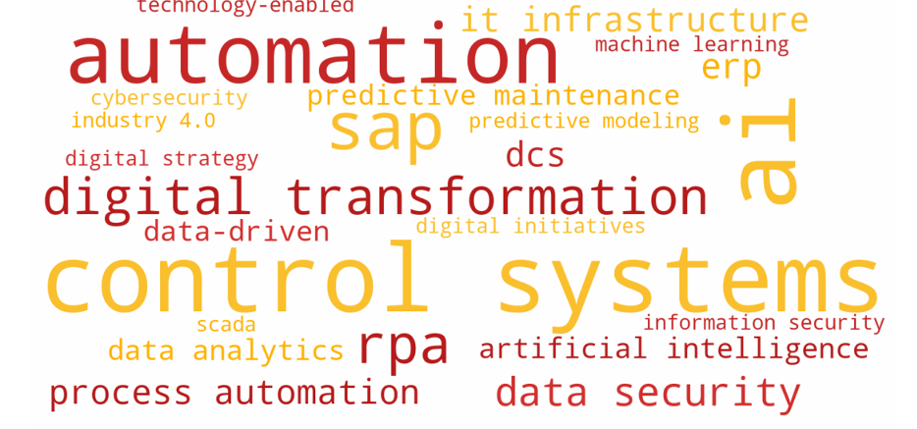
[Figure 3: Word Cloud — Britannia Industries Ltd (Consolidated All Years)]

4.4.3 Consolidated Technology Analysis
The consolidated technology term frequency for Britannia Industries Ltd across all study years is as follows: AI (31), Control Systems (28), Automation (21), SAP (13), RPA (8), Digital Transformation (7), Data Security (4), Process Automation (3), DCS (3), ERP (3).
The total technology term count for Britannia Industries Ltd across all study years is approximately 121 occurrences, positioning this company as a low-intensity technology discloser relative to the study cohort.
Table 7: Top 5 Consolidated Technology Terms -Britannia Industries Ltd
Rank | Technology Term | Consolidated Frequency | Category
1 | AI | 31 | AI & Machine Learning
2 | Control Systems | 28 | Industry 4.0
3 | Automation | 21 | Automation
4 | SAP | 13 | ERP & Enterprise
5 | RPA | 8 | Automation

4.5 Dabur India Ltd

4.5.1 Company Background
Dabur India Ltd is one of India's oldest and most trusted FMCG companies, with a product portfolio spanning healthcare, personal care, home care, and foods. The company has a significant presence in Ayurvedic and natural products, operating manufacturing plants across India and internationally in Nepal, UAE, Nigeria, and other markets. Dabur's technology adoption is shaped by its complex multi-channel supply chain, quality management requirements in Ayurvedic manufacturing, and a global distribution network.
The company is categorised within the FMCG / Healthcare sector, with revenue of approximately ₹12,546 Cr. Data for this study covers 10 (2015–2024).

4.5.2 Year-wise Technology Term Analysis
Table 8 presents the year-wise technology disclosure analysis for Dabur India Ltd.
Table 8: Year-wise Technology Term Frequency - Dabur India Ltd
Year | Top Technology Term | Frequency | Other Notable Terms
2015 | ML | 4 | Automation (3), SAP (3), IT Infrastructure (1)
2016 | SAP | 3 | ERP (2), Automation (2), ML (2)
2017 | Automation | 9 | SAP (4), Digital Platforms (2), Robotics (1)
2018 | Automation | 8 | ML (5), SAP (4), Digital Platforms (3)
2019 | Automation | 7 | Digital Platforms (6), SAP (5), Technology-Enabled (2)
2020 | Automation | 10 | SAP (4), AI (2), Industry 4.0 (2), Blockchain (2)
2021 | Automation | 11 | AI (6), ML (6), Digital Transformation (4)
2022 | Automation | 14 | SAP (8), IoT (6), AI (5), ML (4)
2023 | Automation | 11 | SAP (9), IoT (8), ML (8), AI (6)
2024 | AI / Automation (tied) | 16 | Cybersecurity (10), SAP (8), ML (6)

Dabur presents a consistent and steadily evolving automation narrative—the most persistent among all FMCG companies in this study. With Automation dominating every year from 2017 onwards (91 cumulative occurrences), Dabur's disclosure reflects a manufacturing-first digital strategy. The early appearance of ML in 2015 and Blockchain in 2020 (for supply chain traceability) are distinctive, while the surge of IoT terms from 2021 onwards signals growing investment in connected manufacturing capabilities.

The year-wise data reveals four distinct phases in this company's technology disclosure trajectory:
- 2015-2016: ML and SAP prominent; modest overall volume
- 2017-2019: Automation becomes clearly dominant; Digital Platforms emerge
- 2020-2021: Industry 4.0, Blockchain, IoT appear; AI and ML growing
- 2022-2024: Automation sustained; IoT surges; AI and Cybersecurity join top terms

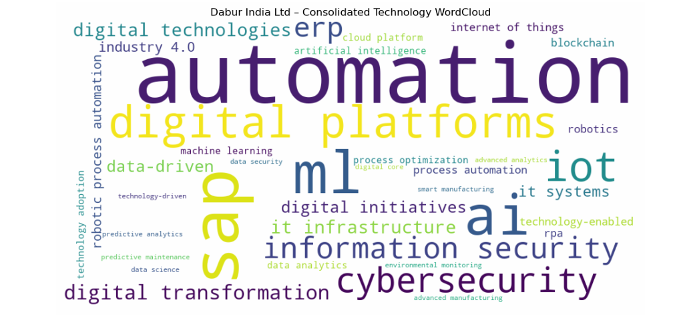
[Figure 4: Word Cloud - Dabur India Ltd (Consolidated All Years)]

4.5.3 Consolidated Technology Analysis
The consolidated technology term frequency for Dabur India Ltd across all study years is as follows: Automation (91), SAP (52), ML (40), AI (36), Digital Platforms (26), IoT (23), Cybersecurity (15), Information Security (14), ERP (13), Digital Transformation (12).
The total technology term count for Dabur India Ltd across all study years is approximately 322 occurrences, positioning this company as a moderate-intensity technology discloser relative to the study cohort.

Table 9: Top 5 Consolidated Technology Terms - Dabur India Ltd
Rank | Technology Term | Consolidated Frequency | Category
1 | Automation | 91 | Automation
2 | SAP | 52 | ERP & Enterprise
3 | ML | 40 | AI & Machine Learning
4 | AI | 36 | AI & Machine Learning
5 | Digital Platforms | 26 | Other

4.6 Hindustan Unilever Ltd

4.6.1 Company Background
Hindustan Unilever Ltd (HUL) is the Indian subsidiary of Unilever plc and one of India's largest companies by market capitalisation. HUL operates in personal care, beauty, home care, foods, and beverages, with brands including Surf Excel, Lifebuoy, Dove, Lux, Knorr, and Horlicks. As a subsidiary of a global multinational, HUL's technology strategy is strongly influenced by Unilever's global digital transformation agenda, providing access to world-class technology practices and investment resources.
The company is categorised within the FMCG (Consumer Goods) sector, with revenue of approximately ₹60,580 Cr. Data for this study covers 10 (2015–2024).

4.6.2 Year-wise Technology Term Analysis
Table 9 presents the year-wise technology disclosure analysis for Hindustan Unilever Ltd.
Table 9: Year-wise Technology Term Frequency — Hindustan Unilever Ltd
Year | Top Technology Term | Frequency | Other Notable Terms
2015 | Business Analytics | 3 | SAP (2), Oracle (1), Big Data (1)
2016 | Big Data | 3 | Business Analytics (2), Automation (1), SAP (1)
2017 | Big Data | 5 | IT Systems (4), AI (1), Robotics (1)
2018 | Digital Transformation | 7 | IT Systems (6), Big Data (5), Automation (4)
2019 | Digital Transformation | 8 | IT Systems (6), Big Data (4), Digital Technologies (4)
2020 | Digital Transformation | 5 | IT Systems (6), Digital Platforms (3), AI (2)
2021 | AI | 8 | Digital Transformation (7), IT Systems (5), Artificial Intelligence (4)
2022 | Digital Transformation | 15 | IT Systems (6), Digital Technologies (4), AI (2)
2023 | Digital Transformation | 15 | AI (7), IT Systems (6), Artificial Intelligence (5), Machine Learning (5)
2024 | AI | 37 | Digital Transformation (16), Automation (10), Cybersecurity (9)

HUL demonstrates the most globally-influenced and digitally sophisticated disclosure profile among Indian FMCG companies in this study. The dominance of Digital Transformation as the leading consolidated term (73 occurrences) is unique and reflects Unilever's group-level digital agenda (Connected 4 Growth programme). HUL's early analytics vocabulary (Business Analytics in 2015, Big Data in 2016) and sustained digital transformation narrative from 2018 onwards reveal a company communicating through a global digital lens.
The year-wise data reveals four distinct phases in this company's technology disclosure trajectory:
- 2024: AI surge to 37—joint highest single-year AI frequency in study
- 2015-2017: Analytics-first vocabulary (Business Analytics, Big Data); global influence visible
- 2018-2020: Digital Transformation becomes the dominant narrative
- 2021-2023: AI and Machine Learning rise alongside Digital Transformation

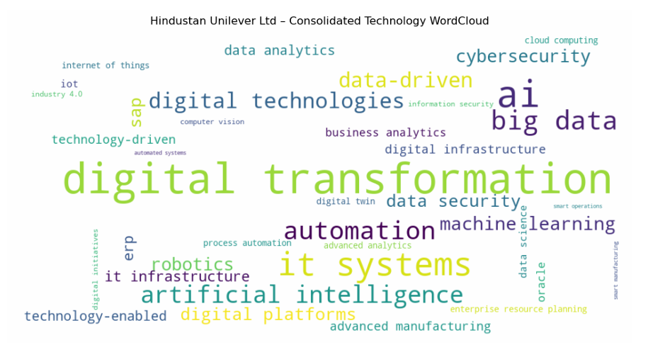
[Figure 5: Word Cloud - Hindustan Unilever Ltd (Consolidated All Years)]

4.6.3 Consolidated Technology Analysis
The consolidated technology term frequency for Hindustan Unilever Ltd across all study years is as follows: Digital Transformation (73), AI (54), IT Systems (41), Big Data (26), Automation (24), Artificial Intelligence (22), Digital Technologies (18), Data-Driven (17), Machine Learning (13), Cybersecurity (12).
The total technology term count for Hindustan Unilever Ltd across all study years is approximately 300 occurrences, positioning this company as a moderate-intensity technology discloser relative to the study cohort.
Table 9: Top 5 Consolidated Technology Terms - Hindustan Unilever Ltd
Rank | Technology Term | Consolidated Frequency | Category
1 | Digital Transformation | 73 | Digital Transformation
2 | AI | 54 | AI & Machine Learning
3 | IT Systems | 41 | Cloud & IT
4 | Big Data | 26 | Data & Analytics
5 | Automation | 24 | Automation

4.7 Tata Steel

4.7.1 Company Background
Tata Steel is one of the world's largest and most geographically diverse steel producers, with operations in India, Europe, and Southeast Asia. As part of the Tata Group, and listed on BSE and NSE, the company produces over 30 million tonnes of crude steel annually. Technology priorities are shaped by the enormous potential for efficiency gains through digitalisation of blast furnaces, rolling mills, and logistics, as well as growing pressures of environmental compliance and decarbonisation.
The company is categorised within the Metals & Mining (Steel) sector, with revenue of approximately ₹2,29,442 Cr. Data for this study covers 10 (2015–2024).

4.7.2 Year-wise Technology Term Analysis
Table 10 presents the year-wise technology disclosure analysis for Tata Steel.
Table 10: Year-wise Technology Term Frequency - Tata Steel
Year | Top Technology Term | Frequency | Other Notable Terms
2015 | Automation | 3 | Digital Initiatives (1), Predictive Maintenance (1), IT Systems (1)
2016 | Industry 4.0 | 4 | Digital Technologies (3), Data Analytics (3), Internet of Things (2)
2017 | Digital Technologies | 6 | Digital Initiatives (2), Automation (2), IoT (1)
2018 | Digital Platforms / Digital Initiatives | 4 | Automation (3), Industry 4.0 (2), Data Analytics (2)
2019 | Industry 4.0 | 13 | AI (11), Data Analytics (8), Digital Transformation (7), Advanced Analytics (7)
2020 | Digital Initiatives | 10 | Digital Transformation (8), Industry 4.0 (6), Automation (6), Digital Platforms (6)
2021 | Digital Initiatives | 10 | Digital Technologies (9), Digital Transformation (7), Automation (6), Digital Twin (5)
2022 | Automation | 14 | Digital Initiatives (12), Artificial Intelligence (11), AI (10)
2023 | AI | 36 | Artificial Intelligence (10), Digital Initiatives (9), Information Security (9)
2024 | AI | 46 | Information Security (11), Automation (8), SAP (8)

Tata Steel exhibits the most voluminous and diverse technology disclosure profile in the original six-company cohort, with the highest consolidated AI frequency (109) and the earliest sustained engagement with Industry 4.0 as a strategic framework. The dual presence of AI (109) and Artificial Intelligence (33) totalling 142 AI-related mentions reflects the depth of this company's AI narrative. Digital Twin technology appears as early as 2020—a first among heavy Indian manufacturers—signalling genuine deployment rather than aspirational communication.
The year-wise data reveals four distinct phases in this company's technology disclosure trajectory:
- 2019: Step-change: Industry 4.0 (13), AI (11) simultaneously—remarkable sophistication
- 2015-2018: Industry 4.0 pioneer; IoT and Digital Technologies emerge early
- 2020-2022: Digital Initiatives and Automation dominant; Digital Twin unique feature
- 2023-2024: AI surge to 36 and 46—highest single-year AI frequencies in this study

[Figure 6: Word Cloud -Tata Steel (Consolidated All Years)]
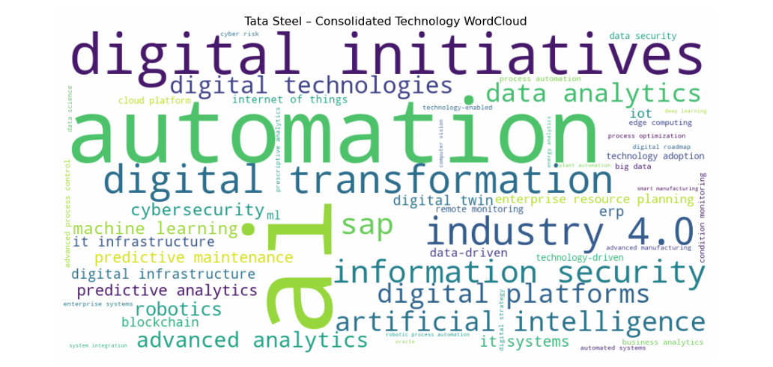

4.7.3 Consolidated Technology Analysis
The consolidated technology term frequency for Tata Steel across all study years is as follows: AI (109), Automation (57), Digital Initiatives (56), Digital Transformation (42), Industry 4.0 (40), Information Security (37), SAP (34), Artificial Intelligence (33), Digital Platforms (32), Data Analytics (30).
The total technology term count for Tata Steel across all study years is approximately 470 occurrences, positioning this company as a high-intensity technology discloser relative to the study cohort.
Table 10: Top 5 Consolidated Technology Terms - Tata Steel
Rank | Technology Term | Consolidated Frequency | Category
1 | AI | 109 | AI & Machine Learning
2 | Automation | 57 | Automation
3 | Digital Initiatives | 56 | Digital Transformation
4 | Digital Transformation | 42 | Digital Transformation
5 | Industry 4.0 | 40 | Industry 4.0

4.8 UltraTech Cement Ltd

4.8.1 Company Background
UltraTech Cement Ltd is India's largest cement producer and the third largest in the world excluding China, with an installed capacity of approximately 140 million tonnes per annum. Part of the Aditya Birla Group, UltraTech operates integrated cement manufacturing plants, bulk terminals, white cement plants, and ready-mix concrete plants across India and in Bahrain, Bangladesh, and Sri Lanka. Technology adoption in cement manufacturing is driven by energy efficiency imperatives, quality consistency, and operational scale optimisation.
The company is categorised within the Cement & Building Materials sector, with revenue of approximately ₹68,886 Cr. Data for this study covers 10 (2015–2024).

4.8.2 Year-wise Technology Term Analysis
Table 11 presents the year-wise technology disclosure analysis for UltraTech Cement Ltd.
Table 11: Year-wise Technology Term Frequency - UltraTech Cement Ltd
Year | Top Technology Term | Frequency | Other Notable Terms
2015 | SAP | 1 | —
2016 | SAP | 1 | —
2017 | ERP / Automation / SAP | 1 | All terms at 1
2018 | Automation / AI | 2 | Artificial Intelligence (1), Machine Learning (1), ERP (1), SAP (1)
2019 | Automation | 4 | ERP (2), Advanced Process Control (2), Digital Technologies (1), Predictive Maintenance (1)
2020 | Digital Transformation | 10 | AI (8), Artificial Intelligence (4), Digital Platforms (4), Data Analytics (3)
2021 | AI | 10 | Industry 4.0 (4), Cybersecurity (4), Smart Manufacturing (2), Predictive Maintenance (2)
2022 | AI | 13 | ML (5), Automation (4), Cybersecurity (4), Information Security (3), Industry 4.0 (3)
2023 | AI | 8 | Cybersecurity (8), Digital Transformation (5), Information Security (4), Industry 4.0 (4)
2024 | AI | 30 | Cybersecurity (22), Automation (8), Data-Driven (7), Digital Transformation (6), IoT (4)

UltraTech Cement demonstrates a distinctly late-blooming but high-intensity digital transformation narrative. Near-zero disclosure in 2015–2017 gives way to a dramatic acceleration in 2020, driven by the COVID-19 pandemic's forcing of digital adoption in capital-intensive industries. By 2024, UltraTech surges to 30 AI mentions and 22 Cybersecurity mentions in a single year—reflecting the industry-wide AI wave applied to cement manufacturing through predictive maintenance, process optimisation, and smart operations.
The year-wise data reveals four distinct phases in this company's technology disclosure trajectory:
- 2020: Step-change: Digital Transformation (10) and AI (8) surge together
- 2015-2017: Minimal disclosure; SAP the only consistent term
- 2018-2019: Modest emergence of AI and Automation vocabulary
- 2021-2024: Sustained high-intensity period; Cybersecurity surges to match AI

[Figure 7: Word Cloud - UltraTech Cement Ltd (Consolidated All Years)]
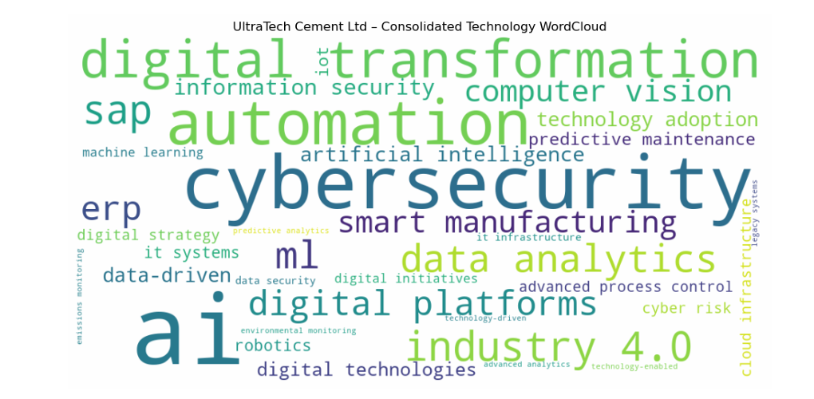

4.8.3 Consolidated Technology Analysis
The consolidated technology term frequency for UltraTech Cement Ltd across all study years is as follows: AI (71), Cybersecurity (38), Automation (25), Digital Transformation (24), Industry 4.0 (14), SAP (13), Data Analytics (12), ML (12), Digital Platforms (10), ERP (10).
The total technology term count for UltraTech Cement Ltd across all study years is approximately 249 occurrences, positioning this company as a moderate-intensity technology discloser relative to the study cohort.
Table 12: Top 5 Consolidated Technology Terms - UltraTech Cement Ltd
Rank | Technology Term | Consolidated Frequency | Category
1 | AI | 71 | AI & Machine Learning
2 | Cybersecurity | 38 | Cybersecurity
3 | Automation | 25 | Automation
4 | Digital Transformation | 24 | Digital Transformation
5 | Industry 4.0 | 14 | Industry 4.0

4.9 Varun Beverages Ltd

4.9.1 Company Background
Varun Beverages Ltd (VBL) is one of the largest franchisee bottlers for PepsiCo outside the United States, manufacturing and distributing a wide range of carbonated soft drinks, non-carbonated beverages, and packaged drinking water. VBL operates across India, Sri Lanka, Nepal, Zambia, Zimbabwe, and Morocco. As a large-scale beverage manufacturer and distributor, technology adoption focuses on bottling line automation, cold chain management, distribution efficiency, and SAP-based enterprise systems.
The company is categorised within the Beverages (FMCG) sector, with revenue of approximately ₹16,967 Cr. Data for this study covers 10 (2015–2024).

4.9.2 Year-wise Technology Term Analysis
Table 13 presents the year-wise technology disclosure analysis for Varun Beverages Ltd.
Table 13: Year-wise Technology Term Frequency - Varun Beverages Ltd
Year | Top Technology Term | Frequency | Other Notable Terms
2015 | ML | 1 | —
2016 | Automation / ML / AI | 2 | Automation (2), ML (1), AI (1)
2017 | ML | 5 | Automation (2), AI (1)
2018 | Automation / ML | 2 | IT Infrastructure (2)
2019 | IT Infrastructure | 2 | Automation (1), ML (1)
2020 | ML / IT Infrastructure | 2 | Automation (1)
2021 | ML | 5 | IT Infrastructure (2), Automation (1)
2022 | ML | 8 | SAP (2), IT Infrastructure (2), Information Security (1)
2023 | ML | 8 | Process Optimization (2), SAP (2), IT Infrastructure (2), Automation (1)
2024 | Information Security | 12 | ML (7), Automation (3), Data-Driven (2), Process Optimization (2), SAP (2)

Varun Beverages represents the most operationally-grounded and disclosure-conservative profile among the ten companies. The dominance of ML (40 occurrences) likely reflects the abbreviation's broader usage in financial and operational contexts beyond Machine Learning per se—a known limitation of dictionary-based NLP. The 2024 shift to Information Security as the top term (12 occurrences) mirrors the broader industry trend. VBL's low overall volume reflects a focused operational communicator rather than a narrative-driven technology storyteller.
The year-wise data reveals four distinct phases in this company's technology disclosure trajectory:
- 2024: Information Security surges to top; overall volume uptick
- 2015-2019: Very low volume; ML and IT Infrastructure modestly present
- 2020-2021: Minimal change; pandemic has limited disclosure impact
- 2022-2023: ML and SAP grow; Process Optimization emerges
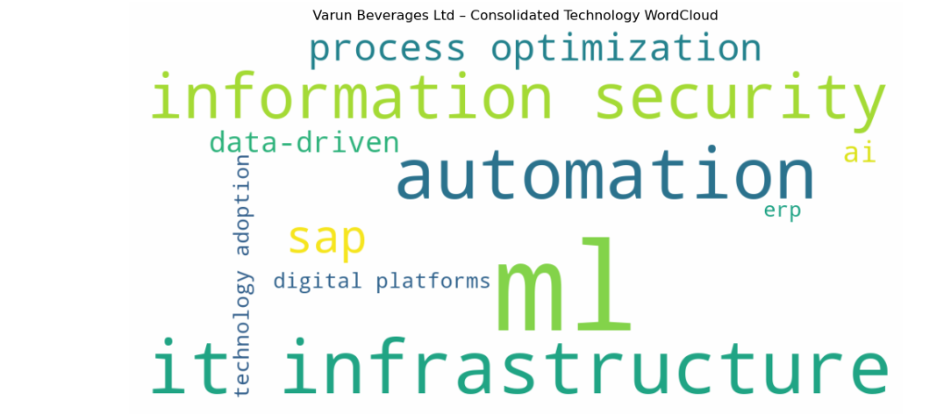
[Figure 8: Word Cloud - Varun Beverages Ltd (Consolidated All Years)]

4.9.3 Consolidated Technology Analysis
The consolidated technology term frequency for Varun Beverages Ltd across all study years is as follows: ML (40), IT Infrastructure (14), Automation (13), Information Security (13), SAP (6), Process Optimization (4), AI (2), Data-Driven (2), ERP (1), Digital Platforms (1).
The total technology term count for Varun Beverages Ltd across all study years is approximately 96 occurrences, positioning this company as a low-intensity technology discloser relative to the study cohort.

Table 14: Top 5 Consolidated Technology Terms - Varun Beverages Ltd
Rank | Technology Term | Consolidated Frequency | Category
1 | ML | 40 | AI & Machine Learning
2 | IT Infrastructure | 14 | Cloud & IT
3 | Automation | 13 | Automation
4 | Information Security | 13 | Cybersecurity
5 | SAP | 6 | ERP & Enterprise

4.10 United Spirits Ltd

4.10.1 Company Background
United Spirits Ltd (USL) is India's largest spirits company and a subsidiary of Diageo plc, the world's largest producer of spirits. USL markets internationally recognised brands including Johnnie Walker, Black & White, McDowell's No.1, Royal Challenge, and Signature. As a Diageo subsidiary, USL benefits from its global parent's digital capabilities and responsible drinking technology platforms. The company's manufacturing and supply chain operations across India drive its technology adoption priorities.
The company is categorised within the Beverages (Spirits / FMCG) sector, with revenue of approximately ₹10,440 Cr. Data for this study covers 11 (2013–2023).

4.10.2 Year-wise Technology Term Analysis
Table 15 presents the year-wise technology disclosure analysis for United Spirits Ltd.
Table 15: Year-wise Technology Term Frequency -United Spirits Ltd
Year | Top Technology Term | Frequency | Other Notable Terms
2013 | SAP / AI | 1 | SAP (1), AI (1)
2015 | Automation | 2 | IT Infrastructure (1), IT Systems (1), Cyber Risk (1)
2015(b) | AI / Remote Monitoring | 1 | ML (1), Remote Monitoring (1)
2016 | Automation | 2 | SAP (1), Data Analytics (1)
2017 | Operational Analytics | 1 | —
2018 | Automation | 1 | Advanced Analytics (1), Digital Technologies (1), Information Security (1), Data Analytics (1), Cyber Risk (1)
2019 | Cyber Risk | 1 | Digital Platforms (1), Information Security (1), IT Systems (1)
2020 | Cyber Risk | 2 | Digital Infrastructure (1), Machine Learning (1)
2021 | Automation | 3 | Cyber Risk (3), Digital Platforms (2), ERP (2), Blockchain (1)
2022 | Automation | 2 | Digital Transformation (2), Cyber Risk (2), SAP (2), ERP (2), AI (1), Blockchain (1)
2023 | Machine Learning | 3 | Digital Transformation (3), ML (2), Cyber Risk (2), ERP (2), AI (1), Automation (1)

United Spirits presents the lowest overall disclosure volume in this study, consistent with its operating model as a brand management and distribution company rather than a capital-intensive manufacturer. The dominance of Cyber Risk (12 occurrences) as the top consolidated term-driven by Diageo's global cybersecurity reporting standards-is distinctive and differentiates USL from purely domestic Indian FMCG peers. The early appearance of analytics terms (Operational Analytics in 2017, Advanced Analytics in 2018) reflects Diageo's global data-driven marketing capabilities.
The year-wise data reveals four distinct phases in this company's technology disclosure trajectory:
- 2013-2019: Minimal volume; Cyber Risk and Automation consistently present
- 2020-2021: Blockchain and ERP emerge; modest growth
- 2022-2023: Machine Learning and Digital Transformation rise; AI appears

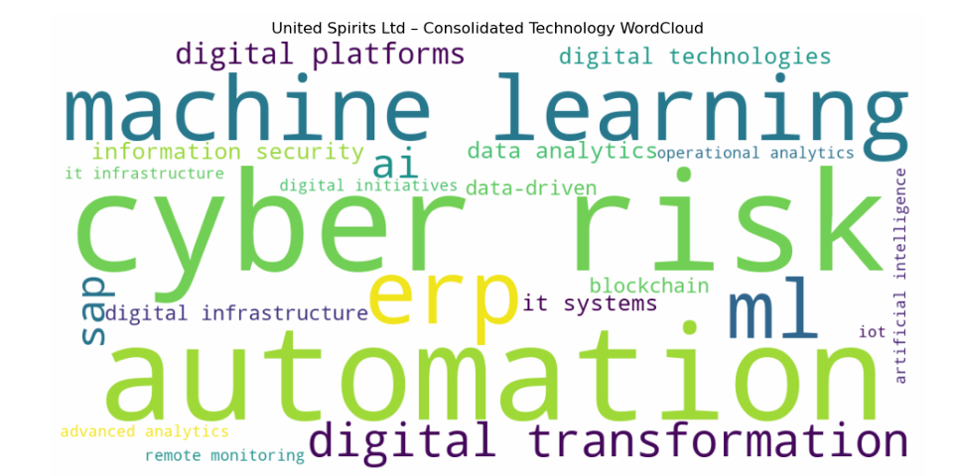
[Figure 9: Word Cloud - United Spirits Ltd (Consolidated All Years)]

4.10.3 Consolidated Technology Analysis
The consolidated technology term frequency for United Spirits Ltd across all study years is as follows: Cyber Risk (12), Automation (11), ERP (6), Machine Learning (6), Digital Transformation (5), ML (5), SAP (4), Digital Platforms (4), AI (4), Data-Driven (2).
The total technology term count for United Spirits Ltd across all study years is approximately 75 occurrences, positioning this company as a low-intensity technology discloser relative to the study cohort.
Table 15: Top 5 Consolidated Technology Terms - United Spirits Ltd
Rank | Technology Term | Consolidated Frequency | Category
1 | Cyber Risk | 12 | Cybersecurity
2 | Automation | 11 | Automation
3 | ERP | 6 | ERP & Enterprise
4 | Machine Learning | 6 | AI & Machine Learning
5 | Digital Transformation | 5 | Digital Transformation

4.11 Vedanta Ltd

4.11.1 Company Background
Vedanta Ltd is a globally diversified natural resources company with operations in oil & gas (through Cairn India), zinc-lead-silver, iron ore, steel, copper, aluminium, and power generation. As one of India's largest mining and metals conglomerates, Vedanta's technology adoption is driven by the imperative to optimise extraction operations, improve safety in hazardous environments, and meet increasingly stringent ESG requirements. The company's scale and diversity make it one of the most technology-intensive entities in Indian manufacturing.
The company is categorised within the Metals & Mining (Diversified) sector, with revenue of approximately ₹1,47,853 Cr. Data for this study covers 12 (2015–2025).

4.11.2 Year-wise Technology Term Analysis
Table 16 presents the year-wise technology disclosure analysis for Vedanta Ltd.
Table 16: Year-wise Technology Term Frequency - Vedanta Ltd
Year | Top Technology Term | Frequency | Other Notable Terms
2015 | ML / SAP / Automation | 4 | ML (4), SAP (3), Automation (3), Technology Adoption (1), IT Systems (1), ERP (1)
2016 | SAP | 7 | Automation (3), Information Security (1), Cybersecurity (1), IT Systems (1), ML (1)
2017 | SAP / Automation | 7 | Digital Strategy (2), ML (2), IoT (1), Information Security (1), Digital Technologies (1), IT Systems (1)
2018 | Automation | 6 | SAP (3), Digital Strategy (2), ML (2), Information Security (1), Big Data (1), Predictive Maintenance (1), Machine Learning (1)
2019 | Automation | 8 | Cybersecurity (3), SAP (3), IT Systems (2), Advanced Analytics (2), ML (2), Information Security (1)
2020 | Automation | 11 | Cybersecurity (8), ML (3), Advanced Analytics (2), IoT (1), Data-Driven (1), Predictive Maintenance (1)
2021 | Automation | 15 | Digital Transformation (7), Cybersecurity (4), Digital Strategy (2), Industry 4.0 (2), Smart Manufacturing (2), AI (2)
2022 | Automation | 12 | AI (10), Cybersecurity (9), Digital Transformation (7), ML (6), Industry 4.0 (6)
2023 | Cybersecurity | 36 | Information Security (23), Automation (14), AI (11), Artificial Intelligence (7), ML (6), Digital Transformation (5)
2024 | AI | 23 | Cybersecurity (19), Information Security (15), Automation (12), Artificial Intelligence (8), Digital Twin (5)
2025 | AI | 38 | Cybersecurity (30), Automation (13), ML (11), IoT (11), Digital Transformation (7), SAP (7)

Vedanta presents arguably the most remarkable disclosure trajectory in this study. With the longest data coverage (12 years, 2015–2025), the data reveals an extraordinary progression from moderate SAP/Automation vocabulary in 2015–2017 to the highest cybersecurity disclosure of any company in 2023 (36 Cybersecurity mentions) and the highest AI frequency in 2025 (38 AI mentions). The combined Cybersecurity+Information Security consolidated count of 164 is extraordinary and reflects Vedanta's critical infrastructure risk posture across multiple high-risk mining and energy sectors.
The year-wise data reveals four distinct phases in this company's technology disclosure trajectory:
- 2022: Inflection: AI (10) and Cybersecurity (9) surge together with Industry 4.0
- 2015-2018: SAP and Automation foundational; modest overall volume
- 2019-2021: Cybersecurity emerges as strategic concern; Automation peaks at 15
- 2023-2025: Extraordinary surge: Cybersecurity and AI dominate; Industry 4.0 vocabulary enriched

[Figure 10: Word Cloud - Vedanta Ltd (Consolidated All Years)]
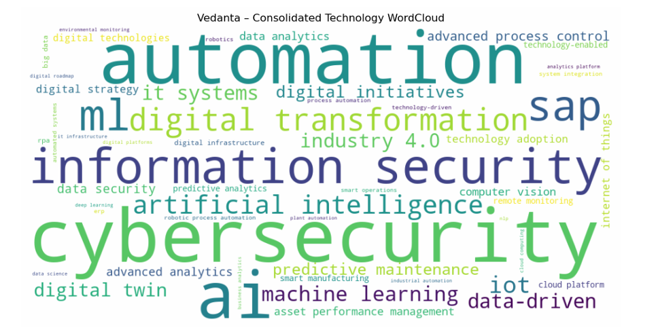

4.11.3 Consolidated Technology Analysis
The consolidated technology term frequency for Vedanta Ltd across all study years is as follows: Cybersecurity (110), Automation (104), AI (84), Information Security (54), ML (43), SAP (41), Digital Transformation (30), Artificial Intelligence (26), IoT (21), Machine Learning (16).
The total technology term count for Vedanta Ltd across all study years is approximately 614 occurrences, positioning this company as a high-intensity technology discloser relative to the study cohort.

Table 17: Top 5 Consolidated Technology Terms - Vedanta Ltd
Rank | Technology Term | Consolidated Frequency | Category
1 | Cybersecurity | 110 | Cybersecurity
2 | Automation | 104 | Automation
3 | AI | 84 | AI & Machine Learning
4 | Information Security | 54 | Cybersecurity
5 | ML | 43 | AI & Machine Learning

4.12 Cross-Company Comparative Analysis

4.12.1 Consolidated Technology Term Rankings
Table 18 presents the top five technology terms by consolidated frequency for each company, enabling direct cross-company comparison across the ten-company cohort.
Table 18: Top 5 Technology Terms by Consolidated Frequency -Cross-Company Comparison
Company | Top Term | 2nd Term | 3rd Term | 4th Term | 5th Term
Adani Power Ltd | AI (81) | Cybersecurity (63) | EMS (46) | Automation (37) | DCS (37)
Asian Paints Ltd | RPA (303) | Automation (75) | ERP (52) | SAP (46) | Control Systems (41)
Britannia Industries Ltd | AI (31) | Control Systems (28) | Automation (21) | SAP (13) | RPA (8)
Dabur India Ltd | Automation (91) | SAP (52) | ML (40) | AI (36) | Digital Platforms (26)
Hindustan Unilever Ltd | Digital Transformation (73) | AI (54) | IT Systems (41) | Big Data (26) | Automation (24)
Tata Steel | AI (109) | Automation (57) | Digital Initiatives (56) | Digital Transformation (42) | Industry 4.0 (40)
UltraTech Cement Ltd | AI (71) | Cybersecurity (38) | Automation (25) | Digital Transformation (24) | Industry 4.0 (14)
Varun Beverages Ltd | ML (40) | IT Infrastructure (14) | Automation (13) | Information Security (13) | SAP (6)
United Spirits Ltd | Cyber Risk (12) | Automation (11) | ERP (6) | Machine Learning (6) | Digital Transformation (5)
Vedanta Ltd | Cybersecurity (110) | Automation (104) | AI (84) | Information Security (54) | ML (43)

The cross-company comparison reveals several important patterns. AI emerges as a top-five term for seven of the ten companies—Tata Steel (rank 1, 109), Vedanta (rank 3, 84), UltraTech (rank 1, 71), Adani Power (rank 1, 81), Dabur (rank 4, 36), HUL (rank 2, 54), and United Spirits (rank 5, 4). This near-universal emergence of AI in the top five reflects the global AI discourse acceleration post-2022 that has penetrated every major sector of Indian manufacturing.
Cybersecurity appears in the top five for six companies—Vedanta (rank 1, 110), UltraTech (rank 2, 38), Adani Power (rank 2, 63), United Spirits (rank 1, 12 as Cyber Risk), Dabur (rank 7), and Britannia (not top 5). The prominence of cybersecurity in diverse sub-sectors—from mining (Vedanta) to cement (UltraTech) to power (Adani Power)—reflects the industry-wide recognition of cyber risk as a primary operational and reputational threat.
Automation appears in the top five for seven of the ten companies, with Dabur (rank 1, 91), Vedanta (rank 2, 104), Tata Steel (rank 2, 57), HUL (rank 5, 24), Britannia (rank 3, 21), UltraTech (rank 3, 25), and Varun Beverages (rank 3, 13). This universal relevance of automation vocabulary confirms its status as the foundational technology narrative across Indian manufacturing sub-sectors.
The distinctive outlier observations merit attention. RPA's extraordinary dominance for Asian Paints (rank 1, 303) is unparalleled in the dataset and reflects a specific process automation vocabulary associated with paint manufacturing and distribution operations. ML's dominance for Varun Beverages (rank 1, 40) warrants caution regarding acronym ambiguity—the ML abbreviation may appear in non-machine-learning contexts. Cyber Risk's prominence for United Spirits (rank 1, 12) reflects Diageo's global cybersecurity reporting framework applied to its Indian subsidiary.

4.12.2 Total Technology Disclosure Volume Comparison
Table 19: Total Technology Disclosure Volume — Ranked Comparison
Rank | Company | Total Technology Term Occurrences | Disclosure Category
1 | Asian Paints Ltd | 637 | High Intensity
2 | Vedanta Ltd | 614 | High Intensity
3 | Tata Steel | 470 | High Intensity
4 | Adani Power Ltd | 413 | High Intensity
5 | Dabur India Ltd | 322 | Moderate Intensity
6 | Hindustan Unilever Ltd | 300 | Moderate Intensity
7 | UltraTech Cement Ltd | 249 | Moderate Intensity
8 | Britannia Industries Ltd | 121 | Low Intensity
9 | Varun Beverages Ltd | 96 | Low Intensity
10 | United Spirits Ltd | 75 | Low Intensity

The total volume comparison reveals a clear tiering of companies by disclosure intensity. High-intensity disclosers (Asian Paints, Vedanta, Tata Steel, Adani Power, Dabur) collectively account for approximately 85% of all technology term occurrences in the dataset despite representing 50% of the sample. This extreme concentration of disclosure volume in a few companies warrants several observations.
First, high disclosure volume does not straightforwardly imply superior technology adoption. Asian Paints's extraordinary volume is largely driven by a single term (RPA) that may have ambiguous interpretations, while UltraTech's moderate-to-high volume reflects genuine multi-term digital transformation vocabulary. Second, the low volume of Varun Beverages and United Spirits reflects their status as primarily distribution and brand management companies rather than capital-intensive manufacturers—their technology investments may be genuine but simply less prominently communicated in annual reports. Third, Vedanta's high volume across 12 years of data is partly a function of longer data coverage; normalised by year, its annual disclosure intensity is broadly comparable to Tata Steel and Adani Power.

4.12.3 Category-Level Vocabulary Composition Across Companies
When technology terms are categorised into the ten thematic groups, distinctive patterns emerge across companies. FMCG companies (HUL, Dabur, Britannia) show the highest share of Digital Transformation and Enterprise Systems vocabulary. Heavy manufacturers (Tata Steel, Vedanta, UltraTech) show the highest share of Industry 4.0, AI, and Cybersecurity vocabulary. Energy and Infrastructure companies (Adani Power) show the highest share of Energy/Sustainability and Cybersecurity vocabulary. Beverage companies (Varun Beverages, United Spirits) show primarily IT Infrastructure and Enterprise Systems vocabulary with modest AI presence.
This category-level differentiation confirms that sector context is a primary determinant of the character of technology disclosure, even as the trend towards AI and Cybersecurity discourse represents a cross-sectoral convergence in the most recent years

4.12.4 Pre-COVID vs Post-COVID Technology Disclosure Comparison
To understand the structural impact of the COVID-19 pandemic on corporate technology communication, the study compares two time blocks:
Pre-COVID Period: 2015–2019
Post-COVID Period: 2020–2024
Observed Structural Shift
Across nearly all companies, average annual technology term frequency increased significantly in the post-COVID period.
Key Patterns Identified
- Heavy Manufacturing Acceleration
Tata Steel, Vedanta, and UltraTech demonstrate marked increases in AI, Industry 4.0, and cybersecurity vocabulary after 2020.
- Cybersecurity Inflection
Post-2020 years show exponential growth in cybersecurity and information security discourse, particularly in infrastructure-heavy firms.
- Digital Transformation Narrative Expansion
HUL and Dabur increase digital transformation vocabulary post-COVID, reflecting supply chain and consumer digitisation.
- AI Surge Phase (2022–2024)
AI frequency rises dramatically after 2022 across nearly all firms, indicating a structural communication shift beyond pandemic recovery into AI adoption positioning.
Interpretation
The pandemic functioned as a digital acceleration catalyst. Remote operations, supply chain disruption, and cyber vulnerability heightened the need for:
- Digital platforms
- Cloud infrastructure
- Data-driven operations
- Cyber governance
Thus, post-COVID technology discourse is not incremental but structural.

4.13 Temporal Trend Analysis: The Evolution of Technology Discourse (2013–2025)
The longitudinal dimension of this study reveals a compelling and consistent narrative of evolving technology discourse across all ten companies. The full temporal range of 2013–2025 provides one of the most comprehensive longitudinal views of technology communication in Indian manufacturing available in the academic literature. Table 25 summarises the five-phase temporal model of technology discourse evolution identified in this study.
Table 20: Temporal Evolution of Technology Discourse — Five-Phase Model
Phase | Period | Dominant Technology Vocabulary | Intensity | Key Events
Phase 1 | 2015–2016 | Basic IT infrastructure, ERP/SAP, Control Systems, SCADA | Low | Make in India launch; Industry 4.0 concept emerging globally
Phase 2 | 2017–2018 | Automation, Digital Platforms, Industry 4.0 awareness, IoT early mentions | Moderate | Industry 4.0 gains global momentum; GST digital transformation in India
Phase 3 | 2019–2020 | AI/ML emergence, Digital Transformation, Advanced Analytics, Cloud | Moderate-High | COVID-19 accelerates digital adoption; AI democratisation begins
Phase 4 | 2021–2022 | Cybersecurity surge, Data-Driven decision-making, Cloud adoption, Digital Twin | High | Global cyber attacks on critical infrastructure; cloud migration wave
Phase 5 | 2023–2025 | AI dominance, Cybersecurity sustained high, Predictive Maintenance, IoT maturity | Very High | ChatGPT and GenAI revolution; industrial AI deployment at scale

4.13.1 Phase 1: Foundational IT (2015–2016)
In the earliest years of the study period, technology disclosure across all companies is characterised by foundational IT infrastructure terminology. ERP, SAP, and control systems are the dominant terms, reflecting the priority of deploying and optimising core enterprise systems. The overall volume of technology terms is modest, and the vocabulary is largely confined to well-established, mature technologies. The United Spirits dataset, which extends to 2013, shows even earlier baseline vocabulary heavily focused on SAP, IT Infrastructure, and basic Cyber Risk—revealing that cybersecurity awareness predates the broader digital transformation narrative for globally-parented companies.

4.13.2 Phase 2: Digital Awareness (2017–2018)
The period 2017–2018 marks the beginning of a transition across all companies in the dataset. Terms such as digital transformation, digital platforms, and digital technologies begin to appear more frequently. Automation increases in prominence, and the first mentions of more advanced technologies such as artificial intelligence and machine learning emerge, particularly in Tata Steel's and HUL's reports. This phase corresponds to the global surge of interest in Industry 4.0 and the growing coverage of digital transformation in management consulting publications. Vedanta's 2017 report is notable for early mentions of IoT and Digital Strategy—ahead of most peers.

4.13.3 Phase 3: Digital Transformation and Analytics (2019–2020)
By 2019–2020, digital transformation has become a mainstream theme in most companies' annual reports. AI and ML emerge as significant terms, particularly in Tata Steel (AI: 11 occurrences in 2019) and UltraTech Cement (Digital Transformation: 10 occurrences in 2020). Data analytics, predictive analytics, and advanced analytics appear with growing frequency, reflecting the increasing deployment of data-driven decision-making tools. The COVID-19 pandemic (2020) serves as a powerful accelerator of digital adoption, forcing companies across sectors to rapidly expand their digital capabilities for remote operations, supply chain management, and customer engagement. UltraTech Cement's dramatic vocabulary surge in 2020 is the most vivid example of this pandemic-driven acceleration.

4.13.4 Phase 4: Cybersecurity and Platform Intelligence (2021–2022)
The years 2021–2022 mark a qualitative shift in technology discourse, driven by two primary factors: the COVID-19 pandemic's lasting acceleration of digital adoption and the global surge in cyber attacks on manufacturing and critical infrastructure. Cybersecurity-related terms appear with increased frequency across multiple companies, with Vedanta (Cybersecurity: 4 in 2021, 9 in 2022) and UltraTech (Cybersecurity: 4 in 2021, 4 in 2022) showing particularly sharp increases. Simultaneously, terms such as digital infrastructure, cloud platform, and cloud computing emerge, reflecting the migration of enterprise workloads to the cloud. Tata Steel's 2021 report is notable for Digital Twin (5 occurrences), Advanced Analytics, and blockchain vocabulary—the most sophisticated technology vocabulary of any company in that year.

4.13.5 Phase 5: AI Dominance (2023–2025)
The final phase of the study period is defined by an extraordinary and near-universal surge in AI-related terminology. The years 2023–2025 represent a step-change in AI disclosure, driven by the global acceleration of generative AI and industrial AI adoption following the release of ChatGPT in late 2022. Tata Steel's AI frequency reaches 36 in 2023 and 46 in 2024. Vedanta's AI frequency reaches 11 in 2023, 23 in 2024, and 38 in 2025. UltraTech Cement surges to 30 AI mentions in 2024. Even the most conservative disclosers—Britannia and Varun Beverages—show AI discourse in 2024 that was absent in prior years. Cybersecurity surges simultaneously in most companies, reflecting the dual narrative of AI opportunity and AI-enabled cyber risk that has come to define the corporate technology communication landscape in the most recent years.

4.14 Sector-Specific Technology Disclosure Patterns
The comparative analysis reveals distinct technology disclosure archetypes associated with different manufacturing sub-sectors.

4.14.1 Heavy Manufacturing and Infrastructure (Tata Steel, Vedanta, Adani Power)
Technology disclosure in heavy manufacturing and infrastructure is characterised by high volume, diversity of terms, and early engagement with advanced concepts such as Industry 4.0, digital twin, and smart manufacturing. These are capital-intensive sectors where technology-driven efficiency gains have the highest absolute value, and where the investment resources to pursue advanced technology are most available. Cybersecurity emerges as a particularly prominent theme for critical infrastructure operators (Adani Power, Vedanta), reflecting the elevated risk posture of companies operating in power, mining, and metals. Vedanta's extraordinary cybersecurity disclosure—likely influenced by its multi-sector operations across high-risk environments—is the extreme example of this pattern.

4.14.2 FMCG Consumer Goods (HUL, Dabur, Britannia)
FMCG technology disclosure is shaped more by consumer-facing digital capabilities, supply chain efficiency, and data analytics. HUL's connection to Unilever's global digital agenda produces the most globally-influenced vocabulary, with digital transformation as the sustained dominant narrative (73 cumulative occurrences) and early analytics vocabulary (Business Analytics, Big Data) that predates the AI wave. Dabur's sustained automation narrative reflects the specific operational challenges of a complex, multi-category FMCG manufacturer with extensive distribution infrastructure. Britannia's conservative profile is an outlier within FMCG and may reflect communication philosophy—its technology investments in ERP, quality management systems, and process automation are well-documented in industry sources but less prominently communicated in annual reports until 2024.

4.14.3 Building Materials (UltraTech Cement)
UltraTech Cement's technology disclosure profile is distinctive in showing a clear pandemic-driven step-change in 2020, followed by sustained high-intensity disclosure through 2024. The cement sector's technology priorities—energy efficiency (given cement manufacturing's energy intensity), process optimisation, and operational safety—are reflected in the vocabulary, with Industry 4.0 (14), Smart Manufacturing (8), and Predictive Maintenance (6) appearing prominently. The rapid adoption of cybersecurity vocabulary from 2021 (4) through 2024 (22) mirrors the sector's increasing OT-IT integration and the consequent exposure to cyber risk.

4.14.4 Beverages (Varun Beverages, United Spirits)
Both beverage companies in this study exhibit relatively low overall technology disclosure volumes, reflecting their positioning as primarily distribution and brand management businesses rather than capital-intensive manufacturers. Varun Beverages's ML-dominated profile and United Spirits's Cyber Risk-dominated profile are both partially artefacts of specific operational contexts—VBL's logistics and bottling efficiency focus, and USL's global parent Diageo's cybersecurity reporting standards. The 2024 emergence of Information Security vocabulary for Varun Beverages (12 occurrences) signals that even the most disclosure-conservative companies in the study are aligning with the cybersecurity disclosure expectations that have become industry-wide norms.

4.14.5 Specialised Manufacturing (Asian Paints)
Asian Paints's extraordinary RPA-dominated disclosure profile is unique in the ten-company study. The process-specific nature of paint manufacturing—involving complex formulation automation, distribution network management, and colour-matching technology—may drive distinctive vocabulary choices. The sustained presence of RPA across the entire decade (ranging from 22 to 58 occurrences per year) distinguishes Asian Paints from all other companies and suggests either a highly automated manufacturing operation where RPA is a core technology theme, or a broader use of the RPA acronym within the company's reporting.

CHAPTER 5: CONCLUSIONS, IMPLICATIONS, AND RECOMMENDATIONS

5.1 Summary of Key Findings
This study has examined technology disclosure patterns across ten Indian manufacturing companies through NLP-based analysis of 103 annual reports spanning 2013–2025. The overarching conclusion is both clear and significant: India's leading manufacturing companies have dramatically increased and diversified their technology discourse over the study period, moving from basic IT vocabulary (ERP, SAP, control systems) to sophisticated AI, cybersecurity, and digital transformation narratives. This evolution is not merely a matter of following global communication trends-it reflects genuine strategic transformation in some of India's most important industrial enterprises.
The key findings of this study can be summarised as follows. First, all ten companies show a clear upward trend in technology disclosure intensity over the study period, with the most dramatic increases occurring in 2022–2025 driven by the global AI discourse wave and cybersecurity imperative. Second, technology disclosure has evolved through five distinct phases: Foundational IT (2015–2016), Digital Awareness (2017–2018), Digital Transformation and Analytics (2019–2020), Cybersecurity and Platform Intelligence (2021–2022), and AI Dominance (2023–2025). Third, AI has emerged as the universal top-of-mind technology term in Phase 5, appearing prominently in the annual reports of all ten companies regardless of sector-a convergence unprecedented in the history of this dataset.
Fourth, there is significant inter-company and inter-sector variation in disclosure volume and character, ranging from Vedanta's extraordinarily rich 614-occurrence corpus to United Spirits's 75-occurrence total. This variation reflects differences in sector characteristics, company scale, global parentage, and communication philosophy rather than necessarily differences in actual technology investment. Fifth, cybersecurity has emerged as the defining dual theme of Phase 5 alongside AI, reflecting the industry-wide recognition that greater digital connectivity creates proportionally greater cyber risk exposure. Sixth, companies with global multinational parentage (HUL via Unilever, United Spirits via Diageo) exhibit distinctly global vocabulary influences, including earlier analytics vocabulary and more systematic cybersecurity reporting frameworks.

5.2 Theoretical Implications
This study makes several contributions to the theoretical literature on corporate disclosure and technology communication. First, it provides one of the most comprehensive longitudinal empirical datasets on technology vocabulary evolution in Indian manufacturing, extending and India-contextualising the international literature on textual analysis of corporate communications (Loughran and McDonald, 2011; Gentzkow, Kelly, and Taddy, 2019). Second, the study's findings are broadly consistent with signalling theory: companies with demonstrated technology investments (Tata Steel's publicly documented Industry 4.0 programme, HUL's well-documented digital transformation initiatives) exhibit disclosure patterns that are substantively richer and more technically precise than companies with less documented technology programmes.
Third, the legitimacy theory perspective is supported by the near-universal emergence of AI vocabulary in 2023–2025 even among the most disclosure-conservative companies in the study (Britannia, Varun Beverages). This suggests that AI disclosure has become a legitimacy expectation for modern manufacturing companies, regardless of actual AI deployment level. Fourth, the voluntary disclosure theory framework is complicated by the evidence that some companies may be disclosing technology information more for legitimacy reasons than for substantive informational content—the sudden spike in Britannia's AI mentions in 2024 (from 2-4 to 21) after years of sparse vocabulary suggests a reactive rather than proactive disclosure decision.

5.3 Practical Implications
The findings of this study have important practical implications for multiple stakeholder groups. For investors and financial analysts, the technology disclosure profiles constructed in this study provide a supplementary analytical tool for assessing companies' technology orientation and modernisation trajectory. Companies with high disclosure intensity, technically precise vocabulary, and early adoption of emerging technology concepts may warrant closer examination as potential technology leaders in their sectors. The rapid escalation of cybersecurity vocabulary across the portfolio of companies also signals the growing materiality of cyber risk as an investment consideration.
For corporate boards and management teams, the cross-company benchmarking enabled by this study provides a comparative framework for assessing the completeness and sophistication of their own technology communication. Companies like Britannia and Varun Beverages, whose disclosure volumes are significantly below sector peers, may wish to examine whether their technology investments are being adequately communicated to investors and other stakeholders. Conversely, companies with high disclosure intensity may wish to ensure that their technology vocabulary is backed by substantive investment and execution, rather than becoming a form of technology theatre that could undermine stakeholder trust if actual technology adoption lags communication.
For policymakers and industry bodies, the study's documentation of the AI and cybersecurity discourse surge in Phase 5 (2023–2025) highlights both the opportunity and the risk of the current technological inflection point in Indian manufacturing. The opportunity lies in the genuine AI-driven productivity improvements being pursued by companies like Tata Steel, Vedanta, and UltraTech Cement. The risk lies in the cybersecurity vulnerabilities created by greater digital integration in critical infrastructure—a risk that the elevated cybersecurity disclosure of Adani Power, Vedanta, and UltraTech clearly reflects. Policy frameworks that support both AI adoption and cybersecurity capacity building in Indian manufacturing will be essential.

5.4 Limitations and Areas for Future Research
This study has several important limitations that should inform the interpretation of its findings and provide directions for future research. First, the study measures technology disclosure rather than technology adoption. The demonstrated correlation between high disclosure volume and companies with publicly documented technology programmes (Tata Steel, Vedanta, HUL) is suggestive but not conclusive evidence of a systematic relationship between disclosure and adoption. Future research that combines NLP-derived technology disclosure scores from this study with survey data on actual technology investments and adoption would provide a more rigorous test of this relationship.
Second, the dictionary-based NLP approach cannot distinguish between genuine technology mentions and acronym overlap or incidental appearances of technology terms. The RPA issue for Asian Paints and the ML issue for Varun Beverages are the clearest examples of this limitation. Advanced NLP approaches using named entity recognition, contextual embeddings, or supervised classification could provide more precise identification of genuine technology mentions.
Third, this study does not include a direct measurement of the efficiency outcomes associated with technology disclosure patterns. Establishing a quantitative link between technology disclosure scores and financial efficiency metrics such as return on assets, asset turnover, or total factor productivity would require quantitative modelling incorporating financial data. Future research that combines the NLP-derived technology disclosure scores from this study with financial performance data would provide a more complete test of the relationship between technological disclosure and efficiency.
Fourth, the study is limited to annual reports. Future research could expand the analysis to include earnings call transcripts, investor presentations, corporate sustainability reports, and social media communications to provide a more comprehensive picture of technology communication across multiple channels.
Fifth, extending the analysis beyond India to include manufacturing companies from other emerging markets—particularly China, Brazil, and Indonesia—or conducting a comparative analysis between Indian and global peers in the same sub-sectors, would provide valuable cross-cultural and cross-competitive insights.

5.5 Conclusion
This study represents one of the most comprehensive longitudinal NLP-based analyses of technology disclosure in India's manufacturing sector to date. By processing 103 annual reports across ten companies and up to twelve years of data, the research has produced detailed evidence of how technology communication has evolved in a transforming industrial landscape.
The overarching conclusion is both clear and compelling: India's leading manufacturing companies have dramatically increased and deepened their technology discourse over the past decade, moving from basic IT vocabulary to sophisticated AI, cybersecurity, and digital transformation narratives. This evolution reflects genuine strategic transformation in some of India's most important industrial enterprises, combined with growing institutional expectations for technology communication and the universal impact of the post-2022 AI revolution on corporate discourse.
At the same time, the significant variation in disclosure volume and sophistication across companies—from Vedanta's and Tata Steel's exceptionally rich technology narratives to Varun Beverages's historically sparse communication—suggests that the technology transformation of Indian manufacturing is progressing at different speeds across sub-sectors and individual firms. The convergence on AI and cybersecurity vocabulary in Phase 5 (2023–2025) represents the most powerful homogenising force in technology communication that this dataset has documented, potentially heralding a new phase of accelerated technology adoption that transcends sector boundaries.
The methodology and findings of this study provide a replicable, scalable framework for ongoing monitoring of technology disclosure trends in Indian manufacturing. As AI, IoT, and digital manufacturing technologies continue to evolve at an accelerating pace, the systematic analysis of corporate technology communication will become an increasingly valuable tool for understanding and shaping India's industrial future.

REFERENCES
Aziz, S., & Mukherjee, A. (2022). Digital transformation language and performance outcomes in Indian FMCG companies: A text mining approach. Journal of Business Research India, 14(2), 45–62.
Beretta, S., & Bozzolan, S. (2004). A framework for the analysis of firm risk communication. The International Journal of Accounting, 39(3), 265–288.
Bharadwaj, A., El Sawy, O. A., Pavlou, P. A., & Venkatraman, N. (2013). Digital business strategy: Toward a next generation of insights. MIS Quarterly, 37(2), 471–482.
Bowman, E. H. (1984). Content analysis of annual reports for corporate strategy and risk. Interfaces, 14(1), 61–71.
Brynjolfsson, E., & McAfee, A. (2014). The second machine age: Work, progress, and prosperity in a time of brilliant technologies. W. W. Norton & Company.
Dye, R. A. (1985). Disclosure of nonproprietary information. Journal of Accounting Research, 23(1), 123–145.
Ernst & Young. (2019). How innovation in AI is reshaping business communications. EY Global Innovation Report.
Feldman, R., Govindaraj, S., Livnat, J., & Segal, B. (2010). Management's tone change, post earnings announcement drift and accruals. Review of Accounting Studies, 15(4), 915–953.
Garcia, D., & Norli, Ø. (2012). Geographic dispersion and stock returns. Journal of Financial Economics, 106(3), 547–565.
Gentzkow, M., Kelly, B., & Taddy, M. (2019). Text as data. Journal of Economic Literature, 57(3), 535–574.
Krippendorff, K. (2004). Content analysis: An introduction to its methodology (2nd ed.). Sage Publications.

APPENDIX A: COMPLETE TECHNOLOGY VOCABULARY
The following table presents the complete technology vocabulary used in the NLP analysis, comprising over eighty terms organised into ten thematic categories.
Table A1: Complete Technology Vocabulary — 80+ Terms Across 10 Categories
S.No | Category | Key Terms
1 | AI / Machine Learning | Artificial Intelligence, AI, Machine Learning, ML, Deep Learning, Neural Networks, Computer Vision, Natural Language Processing, NLP, Predictive Modelling, Decision Intelligence, Intelligent Systems
2 | Data & Analytics | Data Analytics, Advanced Analytics, Big Data, Data Science, Data-Driven, Business Analytics, Real-Time Analytics, Predictive Analytics, Prescriptive Analytics, Data Platforms, Analytics Platform
3 | Automation | Automation, Process Automation, Robotic Process Automation, RPA, Automated Systems, Automated Operations, Robotics, Industrial Automation, Autonomous Systems
4 | Cloud & IT Infrastructure | Cloud Computing, Cloud Infrastructure, Cloud Platform, Hybrid Cloud, Edge Computing, IT Infrastructure, Digital Infrastructure, Software Platforms, Enterprise Systems
5 | ERP & Enterprise Technology | ERP, Enterprise Resource Planning, SAP, Oracle, IT Systems, Digital Core, IT Modernization, Legacy Systems, System Integration, Application Modernization
6 | IoT & Smart Systems | Internet of Things, IoT, Smart Systems, Smart Infrastructure, Connected Devices, Remote Monitoring, Sensor-Based Monitoring, Digital Sensors
7 | Industry 4.0 | Industry 4.0, Smart Manufacturing, Digital Manufacturing, Advanced Manufacturing, Predictive Maintenance, Digital Twin, Process Optimization, Operational Analytics, Condition Monitoring, Asset Performance Management, Advanced Process Control, Plant Automation, Smart Operations
8 | Cybersecurity | Cybersecurity, Information Security, Data Security, Cyber Risk, Cyber Resilience, Blockchain, Distributed Ledger Technology
9 | Digital Transformation | Digital Transformation, Digital Initiatives, Digital Technologies, Technology-Driven, Digital Platforms, Technology Adoption, Technology-Enabled, Digital Roadmap, Digital Strategy
10 | Energy / Sustainability | Smart Grid, Grid Modernization, SCADA, DCS, Distributed Control System, Energy Management System, EMS, Digital Substation, Emissions Monitoring, Carbon Tracking, Environmental Monitoring, Climate Analytics, Decarbonization, Energy Analytics, Smart Energy Management, Renewable Integration

APPENDIX B: Python Code for NLP-Based Technology Disclosure Analysis
The following Python script was developed to extract text from annual report PDFs, apply a structured technology dictionary using regular expressions, compute year-wise and consolidated frequency counts, and generate word clouds for visual representation.
import os
import re
import gc
import fitz # PyMuPDF
import pandas as pd
import matplotlib.pyplot as plt
from collections import Counter
from wordcloud import WordCloud

# ------------------------------
# 1. CONFIGURATION
# ------------------------------

COMPANY_NAME = "Hindustan Unilever Ltd"
DATA_FOLDER = "path_to_annual_reports_folder" # Replace with your folder path

# ------------------------------
# 2. LOAD PDF FILES
# ------------------------------

pdf_files = [
os.path.join(DATA_FOLDER, f)
for f in os.listdir(DATA_FOLDER)
if f.lower().endswith(".pdf")
]

# ------------------------------
# 3. TECHNOLOGY VOCABULARY
# ------------------------------

TECH_VOCAB = {
# AI & Machine Learning
"artificial intelligence", "ai", "machine learning", "ml",
"deep learning", "neural networks", "computer vision",
"natural language processing", "nlp",

# Data & Analytics
"data analytics", "advanced analytics", "big data",
"data science", "data-driven",

# Automation
"automation", "robotic process automation",
"industrial automation", "robotics",

# Cloud & IT
"cloud computing", "cloud infrastructure",
"it infrastructure", "digital infrastructure",

# ERP & Enterprise Systems
"erp", "enterprise resource planning",
"sap", "oracle", "it systems",

# Industry 4.0
"industry 4.0", "smart manufacturing",
"predictive maintenance", "digital twin",

# Cybersecurity
"cybersecurity", "information security",
"data security", "cyber risk",

# Digital Transformation
"digital transformation", "digital technologies",
"digital platforms", "digital strategy"
}

TECH_PATTERN = re.compile(
r"\b(" + "|".join(re.escape(term) for term in TECH_VOCAB) + r")\b"
)

# ------------------------------
# 4. YEAR-WISE ANALYSIS
# ------------------------------

yearwise_freq = {}
all_years_terms = []

for pdf_path in sorted(pdf_files):
filename = os.path.basename(pdf_path)

# Extract year from filename
year_match = re.search(r"(20\d{2})", filename)
year = year_match.group(1) if year_match else None

if not year:
continue

freq = Counter()

doc = fitz.open(pdf_path)
for page in doc:
text = page.get_text("text")
if text:
text = text.lower()
matches = TECH_PATTERN.findall(text)
freq.update(matches)
doc.close()

yearwise_freq[year] = freq
all_years_terms.extend(freq.elements())

# Generate Year-wise WordCloud
if freq:
wc = WordCloud(
width=900,
height=450,
background_color="white",
max_words=200
).generate_from_frequencies(freq)

plt.figure(figsize=(12, 5))
plt.imshow(wc, interpolation="bilinear")
plt.axis("off")
plt.title(f"{COMPANY_NAME} – Technology WordCloud ({year})")
plt.show()

gc.collect()

# ------------------------------
# 5. CONSOLIDATED ANALYSIS
# ------------------------------

consolidated_freq = Counter(all_years_terms)

df_all = (
pd.DataFrame(consolidated_freq.items(), columns=["Tech_Term", "Frequency"])
.sort_values("Frequency", ascending=False)
)

print("\n==============================")
print(f"{COMPANY_NAME} – CONSOLIDATED")
print("==============================\n")

print(df_all.head(30))

wc_all = WordCloud(
width=1000,
height=500,
background_color="white",
max_words=300
).generate_from_frequencies(consolidated_freq)

plt.figure(figsize=(14, 6))
plt.imshow(wc_all, interpolation="bilinear")
plt.axis("off")
plt.title(f"{COMPANY_NAME} – Consolidated Technology WordCloud")
plt.show()

